Project13 Week2 (11.23-12.6)

This week, we completed all the construction of two paper projects according to the original plan and timeline.

MengyangLi:

Earlier I found that my computer memory was not enough to run this complex project. So try to upload the project to CCV and run it. But later, when I read --help, I found that changing the number of nodes to one can greatly reduce the load on the computer. So, after changing the parameters, I successfully ran the project.

However, I later found that this project could not output the result reselt.txt. After looking at the issue of the project, I found that quite a few people were experiencing the same problem. The author asked us to try to delete one of the parameters "-withGUI". After deleting this parameter, we finally succeeded in getting the result.

Then we need to put the results into the master Jupyter Notebook to visualize the results. So, I re-mirrored the Docker container to host port 8888. Finally, the entire project was rebuilt.

The next step is to use drones to actually test the project.

Result: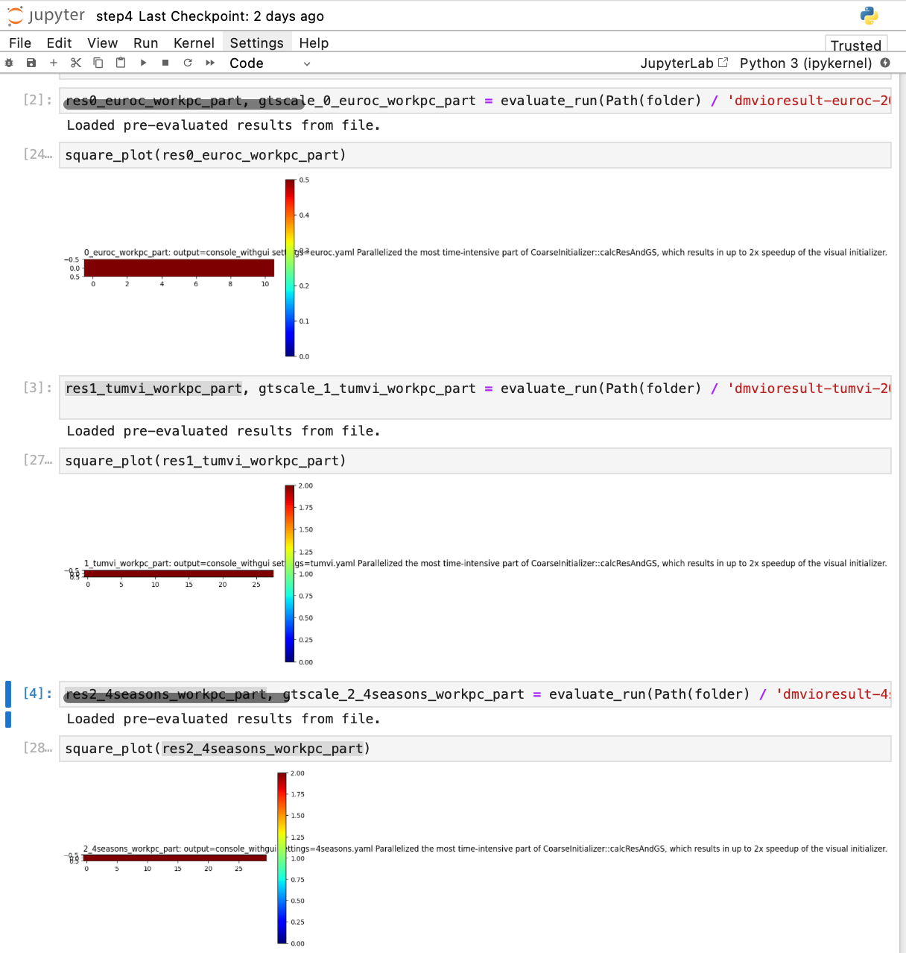  
  
HonglinWu:  
After successfully built the project. I have verified the project on the author’s recorded dataset and EuRoC MAV dataset.

The images below are the outputs of the two datasets.

图示

Next, I plan to use the drones to carry out experiments of our own. I first downloaded the realsense driver and ros wrapper which is required for using our own camera.

Then get the camera information like the author mentioned in the project’ readme: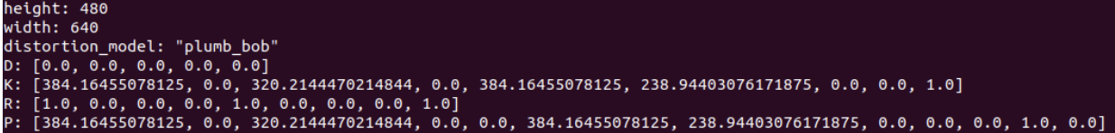After that, I email to the professor to get our drones.

文本

Next step is to do experiments with drones and compare the performance of our primary and secondary paper.